Reference #1
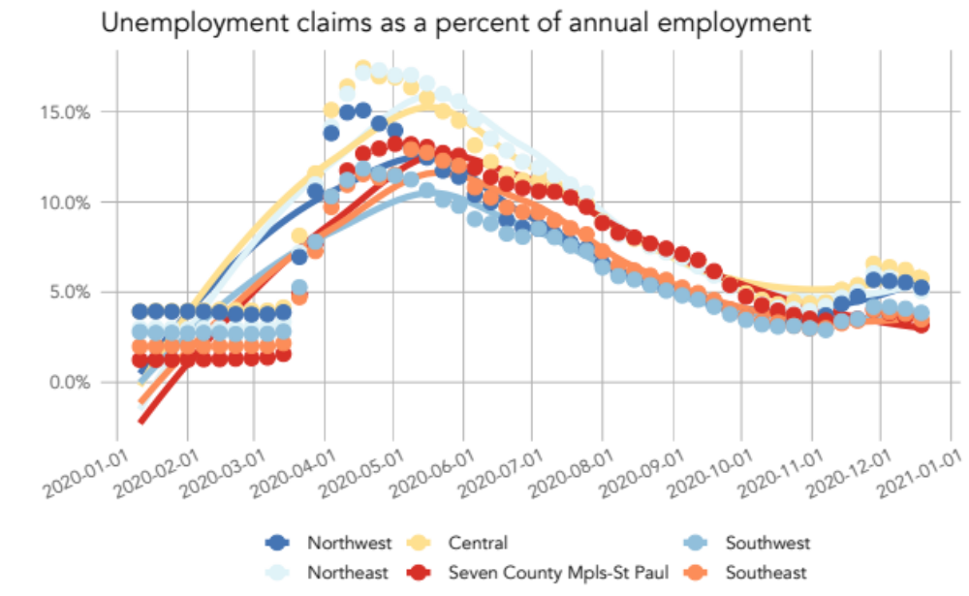
Figure 1: The number of weekly unemployment claims in 2020 as a percentage of total employment for the year 2019 shows an obvious spike during the shutdown of non-essential businesses, then slowly decreases over time. Data: MN DEED – Unemployment Claims | Bureau of Labor Statistics – Occupational Employment Statistics
There has been concern about the increasing continuous unemployment claims through November across the state. However, in Greater Minnesota the rise in unemployment claims is largely expected. Due to the seasonal nature of employment for many industries in rural areas, a majority of the increasing unemployment claims are typical for the time year. Figure 2 provides the difference in the unemployment rate between 2019 and 2020. Not surprisingly, the largest difference occurred in Spring/early summer and has been decreasing since that time. Perhaps a bit surprising, the largest difference occurred and continues to be in the seven-county metro. By the end of November, their unemployment rate was still 1.3 percentage points higher than in 2019. In Greater Minnesota, it’s 1 point or less. This tells us that the rising unemployment claims in November are largely due to seasonal changes that also occurred in 2019 and in previous years.

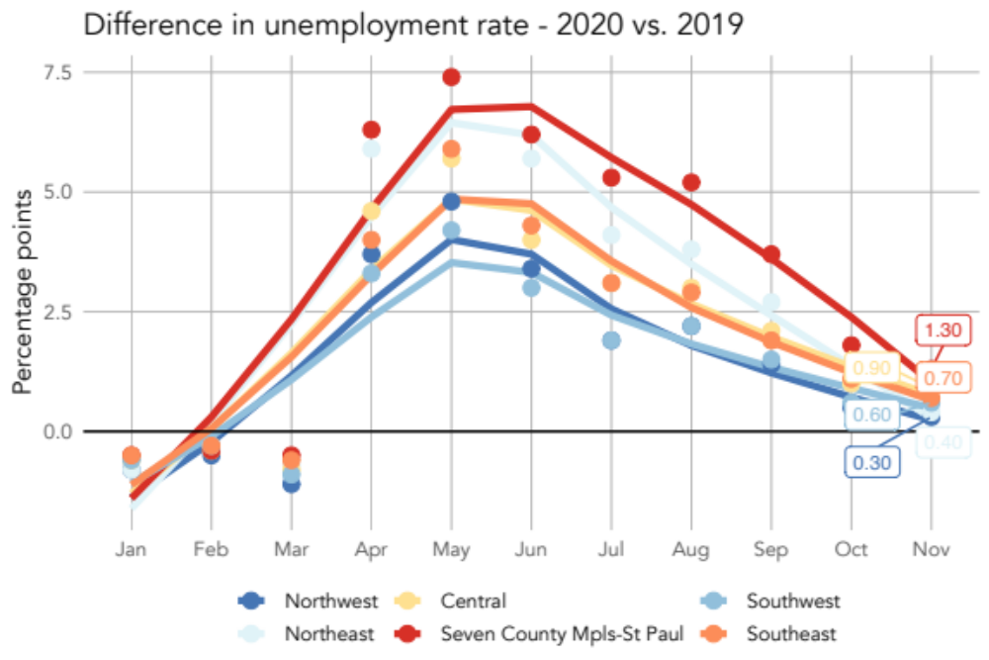
Figure 2: The difference in the unemployment rate between 2019 and 2020 shows a large difference during the peak of the pandemic in early summer. It has largely dropped off in Greater Minnesota by November despite the rising unemployment claims.

Reference #2

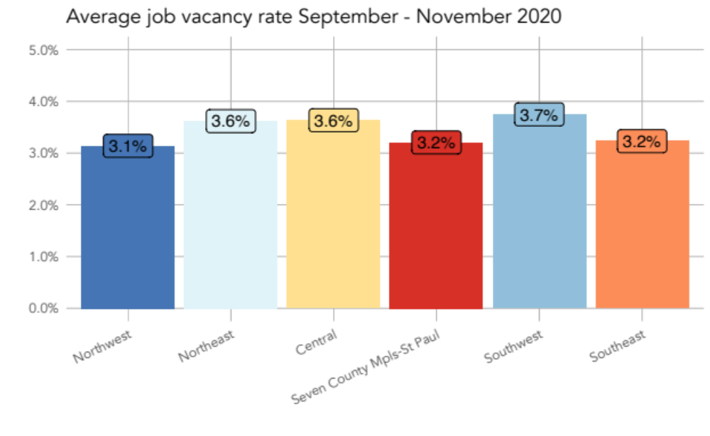
Figure 3: The average job vacancy during September and October 2020 shows job vacancy rates 2 to 3 percentage points lower than the 2019 annual vacancy rate. Data: MN DEED - National Labor Exchange | Bureau of Labor Statistics - Occupational Employment Statistics

Reference #3
However, the difference between 2019 and 2020 is the availability of labor in the unemployment pool. In 2019, the number of individuals on unemployment to tap into was bare. The pandemic has changed that situation and now a larger pool exists. Although that pool is already beginning to shrink. Figure 4 shows that job postings were close to equaling the number of unemployment claims, particularly in rural Minnesota. By the end of October, Southwest Minnesota had nearly just as many job postings than individuals filing for unemployment claims.

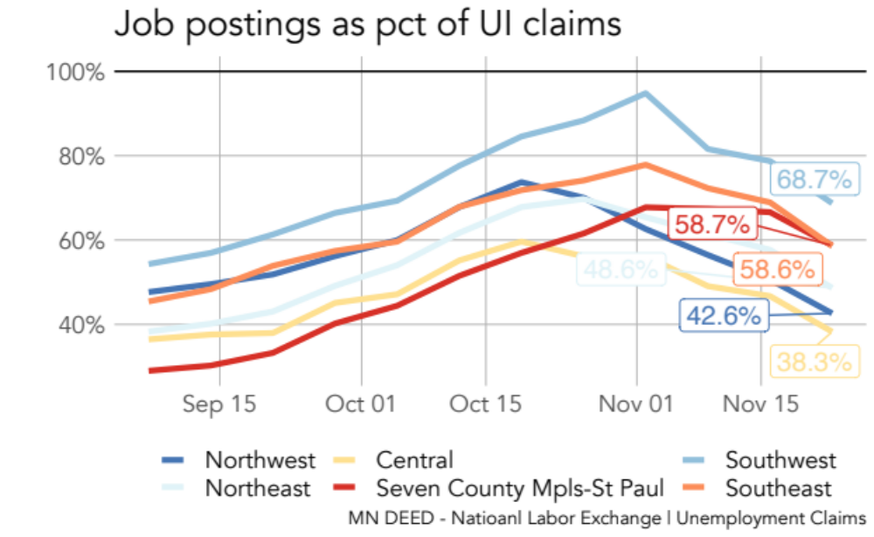
Figure 4: The number of weekly job postings as a percent of weekly unemployment claims has been steadily increasing since September. Note that in Southwest Minnesota, there were more job postings than unemployment claims. Data: MN DEED Unemployment Claims & National Labor Exchange

However, since the end of October, those percentages have decreased significantly. Although one might be quick to believe that increasing COVID-19 cases and the subsequent restrictions put in place impacted the number of jobs available, this wasn’t the case, at least through November (the most recent data available). The number of job positions available in each region through November has remained nearly the same.

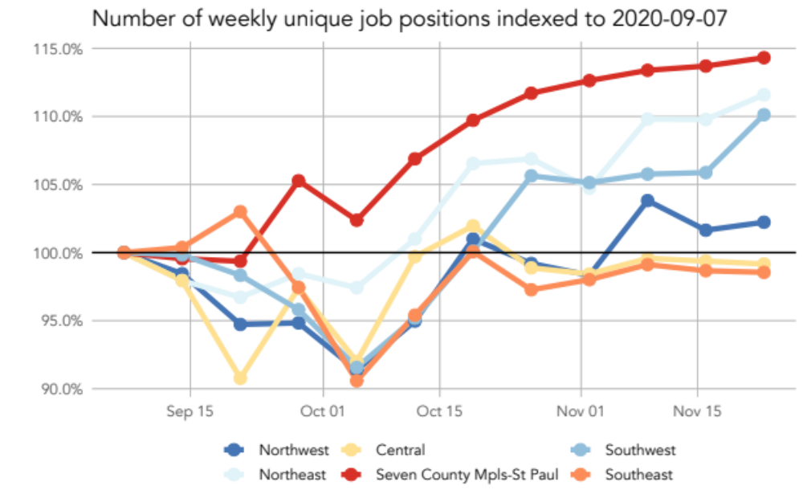
Figure 5: The number of job postings has remained relatively consistent since September. Data: MN DEED - National Labor Exchange

